Seven Loaves Catering & Events

Cocktail Party Menu
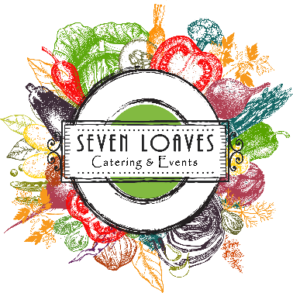

Cocktail Parties
Create a plan
If you plan to serve appetizers before a meal, consider what you will be serving for the dinner portion of the meal and try to select complementary appetizers. Timeline (how long is the event) and timeframe (what time of day is the event) are also contributing factors. If you are hosting an “hors d’oeuvre only” event during a common a meal time (6-8pm for example) guests will eat more compared to a come-and-go open house style event held mid-afternoon.
These are guidelines for hors d’oeuvres set out on a buffet. Every party and every menu have different details which affect the final proposal:
Appetizers w/ a Dinner – 6 appetizers per person. Serve only 2 to 3 appetizers (2-3 pieces of each per person). You want to “wake up” your guests’ palette but not ruin their appetite.
Cocktail Party – 8 to 12 appetizers pieces per person. Guests will generally eat about 5 appetizers each during the first hour and will eat about 3 appetizers each for each subsequent hour. Adding dips or displays could reduce the appetizer count.
*For Butler/Tray Passed hors d’oeuvres the count may be lower; however, additional staff may be required.
THE BEST PART is Seven Loaves Catering’s event planners are the experts and can walk you through every detail. Leave the planning to us, so you can enjoy being a guest at your own party!

Other Things to Consider
A common misconception is “lighter on the food equals lighter on the wallet”. In most cases, cocktail parties are not a less expensive alternative to a full dinner. Keep in mind, the detail and labor involved in hand preparing each item is time consuming. Additionally, some items require “building” on site and therefore are not available for drop-off service. Those items are marked with an * on our menu.

Staffed Events– We will staff your party at a 30 to 1 ratio (with china place settings), or 50 to 1 (with disposable place settings). Butler passed hors d’oeuvres or extensive setup may require additional service staff. Staffed events require a minimum of two servers with a four-hour minimum.
Delivery w/ Set up – A staff member will deliver and set up wire warming chafers and your buffet area for your party. This fee is typically $25-100 depending on the amount of food and travel time. Warming chafers are $10.95 each and do not have to be returned. All food is sent in disposable presentation containers.
Drop off only – Typically $30-45. The food will be delivered to you and you will take over from there! It’s that simple.
Place Settings – China or disposable place settings are another consideration. Cocktail China starts at $2.95 pp and disposable packages range from Free to $2.50 pp.

FINALLY… the FOOD!
Look through our extensive menu to wet your taste buds and jot down a few favorites as well as anything you absolutely would not want. No need to rack your brain with too many options... having just a few of your likes and dislikes will help us make recommendations for you.
Hors D’oeuvres – Pick a few items out depending on your needs (see above recommendations)
Displays – Choose a favorite below
Dips – Hot dips with crackers or house made Tortilla or Potato Chips are a great add-on
Desserts – For those guests with a sweet tooth, choose a delectable item or two

Hors D’oeuvres
Items are prices per dozen
(3 dozen min. of each)
*Ahi Tuna Crisp $48.00
Sesame seared Ahi Tuna on a crisp Wonton with Wasabi & Asian Slaw topped with Pickled Ginger
Antipasto Crostini $36.00
With Salami, Brie, Cranberry Jam and Fresh Mint
Apple Cider Maple Meatballs $48.00
Slow cooked in an apple cider and maple syrup glaze and served on skewers with an apple bite
Assorted Mini Quiche Bites $36.00
An assortment of broccoli cheddar, smoked turkey, and bacon quiche bites
Assorted Pinwheel Wraps $30.00
Spinach, sun-dried tomato, and pepper cheddar tortilla wraps filled with roasted turkey, black forest ham, or roast
beef and our house sandwich spread
Bacon Wrapped Shrimp (GF) $48.00
Pan seared shrimp wrapped in crisp bacon.
Beef Empanadas $48.00
House-made Beef Empanadas served with a Chipotle Mayo Drizzle

Beef Fajita & Cheese Quesadilla $36.00
Beef fajita meat, Pico de Gallo and cotija cheese in flour tortillas served with cilantro lime sour cream
*Blackened Shrimp Tostada (GF) $48.00
Blackened shrimp served on a bite sized tostada with mango salsa and an avocado drizzle.
Braised Mushroom and Smoked Gouda Grit Tartlet (V) $36.00
Creamy grits with smoked Gouda cheese topped with a braised mushroom on a shortbread tart
Brie & Cranberry Phyllo Cup (V) $36.00
Tender phyllo cups filled with Brie cheese and topped with cranberries, pecans and microgreens
Brie and Apricot Lotus Cups (V) $30.00
Warm brie and apricot preserves served in a wonton lotus cup garnished with fresh cilantro
Brisket Stuffed Jalapenos (GF) $48.00
Delicious Jalapeno peppers stuffed with smoked brisket and cheddar wrapped in smoked bacon
Brisket Tacos - Cocktail Style $48.00
Hickory smoked brisket tacos with poblano peppers, cilantro, and honey chipotle sauce
*Bruschetta Bites (V) $30.00
Freshly diced Roma tomato and basil bruschetta served on a toasted crostino
Buffalo Chicken Bite in Wonton Cup $36.00
Creamy and spicy buffalo chicken dip in a bite sized wonton cup
Butternut Squash Potsticker (V) $30.00
With Ponzu Dipping Sauce
Candied Sweet Potato & Spicy Sausage Skewer (GF) $36.00
with Bourbon Maple Glaze
Caprese Skewers (V) (GF) $30.00
Caprese Skewers with fresh mozzarella, grape tomatoes and kalamata olives with basil pesto
Caramelized Apple and Gorgonzola Filled Shortbread Tarts (V) $30.00
Caramelized apple, toasted walnuts, and Gorgonzola filled shortbread tart shells
Caramelized Onion and Cauliflower Quesadilla (V) $30.00
Vegetarian quesadilla with onion, spinach and roasted, chili rubbed cauliflower topped with avocado creme,
charred tomato, and fresh cilantro
Charcuterie Plate $9.00 pp
Served with cured meats, fresh cheeses, seasonal vegetables, fruits and berries, olives, peppers, assorted breads,
nuts, dips and other seasonal accoutrements! Will be individually plated. **Each plate is unique based on the
season
Cheese and Bacon Quesadilla $36.00
Served with sour cream and salsa
Cheese Ball Truffles (V) (GF) $36.00
Rolled balls of our three-cheese blend and Cream Cheese with Green Onion rolled in chopped pecans, crispy
bacon, french fried onions. Skewered with a Pretzel stick and served with crackers
Cheese Quesadilla (V) $30.00
Served with Pico de Gallo, cotija cheese, and cilantro lime sour cream
Cheese Stuffed Mini Peppers (V) $36.00
Mini sweet peppers stuffed with a Jack Cheese, Cream Cheese and Pickled Jalapeno mix and topped with
Japanese breadcrumbs and chopped Cilantro.
*Chicken and Waffle Bite $36.00
Fried chicken and waffle with a vanilla bourbon maple syrup
Chicken Cordon Bleu Bites (GF) $36.00
Marinated grilled chicken breast bite with Smoked Ham and Swiss Cheese on a pic with Dijon Mustard drizzle
Chicken Salad Cucumber Bite (GF) $30.00
Roasted chicken, cranberries, pecans, and chives in a bite of cucumber
Chicken Stuffed Jalapenos (GF) $48.00
Delicious jalapeno peppers stuffed with chicken and smoked Gouda wrapped in smoked bacon
Chimichurri Flank Steak Rom-lade (GF) $48.00
Argentinean mixture of parsley, garlic, onion, vinegar, and oil, adding a nice tang and freshness to thinly sliced
and rolled flank steak with a basil aioli drizzle
Chorizo Quiche Bite $30.00
Topped with a dollop of sour cream
Citrus Marinated Shrimp Cocktail Shooters (GF) $48.00
With a Louis Sauce
Coconut Crusted Shrimp $48.00
Hand-breaded, coconut crusted shrimp with sweet Thai chili sauce
Crab Cake Popper $48.00
Flavorful lump crab cake popper with a sweet and tangy citrus aioli
Cucumber and Goat Cheese Canape (V) $30.00
A crisp cucumber round topped with goat cheese mousse and garnished with a cherry tomato wedge.
Empanadas - Chicken $48.00
Handmade Empanadas - Chicken served with a chipotle cream sauce
*Fajita Chicken Tostada (GF) $36.00
Grilled Fajita Chicken served on a bite sized Tostada with Refried Beans, Pickled Red Onion, Fresh Cilantro and
Cotija Cheese
Figs in a Blanket (V) $36.00
Spicy, honey-glazed figs are balanced by creamy goat cheese and buttery puff pastry in this fun vegetarian play
on pigs-in-a-blanket.
Filo-Wrapped Brie (V) $36.00
Brie cheese in flaky filo with chopped tomatoes, fig, basil and toasted pine nuts
Fire Grilled Rosemary Garlic Chicken Skewer (GF) $30.00
Grilled cuts of chicken breast skewered with fresh rosemary and spicy apricot glaze
French Dip Pinwheels $48.00
French Dip Pinwheels- crescent roll dough is wrapped around roast beef, Provolone cheese and caramelized
onions and baked until golden. Served with Au Jus to dip them in for extra flavor.
Fresh Fruit Skewers (V) (GF) $36.00
Fresh fruit skewered and served with a Honey Yogurt Dip
*Fried Chicken and Pimento Cheese Bite $36.00
Spicy Fried Chicken Bite topped with House Made Pimento Cheese, pickled red onion and a candied jalapeno
Garlic Basil Shrimp (GF) $48.00
with a garlic basil butter sauce
Goat Cheese Canapé (V) $30.00
on a buttered crostini with Goat Cheese Mousse, fresh basil and a sweet tomato jam
Gorgonzola Shrimp $36.00
Seared jumbo shrimp topped with red pepper-gorgonzola butter and garlic breadcrumbs.
Grilled Margarita Lime Shrimp Brochette (GF) $54.00
Grilled fajita shrimp with a hint of tequila, smoked paprika lime butter, and fresh cilantro served 2 to a skewer
Hawaiian Chicken Skewers (GF) $36.00
Boneless Skinless Chicken Thigh Meat, skewered and grilled with fresh pineapple, bell pepper, onion and a
Hawaiian BBQ Glaze
Holiday Deviled Eggs (V) (GF) $30.00
Savory spinach deviled eggs with Roasted Red Pepper
*Honey Butter Chicken and Biscuit Skewer $36.00 Crispy fried chicken glazed with honey butter and buttermilk biscuit on a skewer
*Honey Butter Chicken Biscuit Bites $36.00
Crispy tender fried chicken breast served on a mini flaky buttermilk biscuit with whipped honey butter
*Hummus Crostini (V) $30.00
Buttery toasted crostini with a Red Pepper Hummus spread and topped with mixed Olive Tapenade
Hummus Crudité Shooter (V) (GF) $30.00
Sliced carrots and celery served in a shot glass with white bean hummus
*Macaroni and Cheese Lotus Cup $30.00 Green Chili Macaroni and Cheese served in a wonton lotus cup and garnished with Bacon
Meatballs $36.00
Homemade meatballs served in a rich, cream sauce, Choose from Swiss, Italian, Polynesian, or Turkey and Cranberry

Mini Crab, Spinach, and Mushroom Tarts (V) (GF-some varieties) $48.00
Bite size tarts with crab and mushrooms and spinach
Mini Meatloaf Bite $36.00
A perfectly blended bite of ground sirloin, pork, and ground chuck roast topped with ketchup and a dollop of
whipped potatoes.
Mini Vegetarian Eggrolls (V) $36.00
Flash-fried with Napa cabbage, julienne vegetables, and sweet Thai chili sauce
Muffuletta Bite $36.00
A toasted crostini topped with Hummus spread, salami, ham, and provolone cheese and garnished with olive
tapenade
Peach and Chipotle Chicken Brochettes (GF) $36.00
Skewered and grilled chicken breast with a kick of chipotle are mellowed by grilled peaches and cilantro
Polenta Cake Bites $30.00
With Glazed Ham and Honey Drizzle
Polynesian Chicken Kabob (GF) $36.00
Grilled with zucchini, red pepper, and pineapple with a Hawaiian glaze
Polynesian Pork (GF) $36.00
Tender pieces of pork skewered with pineapple, sweet red onion, cremini mushrooms, and mild red bell pepper.
Grilled and glazed with a sweet and tangy Polynesian sauce.
Pork Pot Stickers $36.00
Ground Pork, Shredded Cabbage and Carrots with garlic, ginger, soy and sesame oil wrapped in a pot sticker
wrapper and fried served with a cranberry teriyaki glaze
Pulled Pork Taco- Cocktail Style $36.00 Mexican Pulled Pork Tacos with slaw, cilantro and Cotija Cheese topped with a Sweet Onion Chipotle Sauce
Salmon Croquettes $36.00
Seasoned and deep-fried Salmon Croquettes served with homemade Tartar Sauce
Sauteed Blue Lump Crab Cakes $48.00
Sautéed blue lump crab cakes with Cajun remoulade
Short Rib and Smoked Gouda Grit Tartlet $48.00
Creamy grits with smoked Gouda cheese topped with slow cooked boneless short rib on a shortbread tart
Shrimp and Smoked Gouda Grit Tartlet $48.00
Creamy grits with smoked Gouda cheese topped with a grilled shrimp on a shortbread tart
Shrimp Ceviche Shooters (GF) $48.00
Served in a shot glass. Choose from Classic, Tequila Lime, or Mango
Smoked Chicken Salad Cup $36.00
Tender shredded, smoked chicken salad in a shortbread cup, topped with pickled onion and candied jalapeno
Southwest Eggroll (V) $36.00
Crispy fried eggroll filled with roasted corn, black beans, and seasoned rice.
Southwest Rumaki (GF) $36.00
Marinated chicken breast bite with water chestnut and jalapeno wrapped in bacon with a Garlic Butter Glaze
Spinach & Goat Cheese Tart (V) $30.00
Baked phyllo cups with a bite-size version of a classic holiday side: cheesy creamed spinach
Spinach and Artichoke Deviled Eggs (V) (GF) $36.00
Hard-boiled eggs with a creamy spinach and artichoke filling
Spinach Artichoke Lotus Cups (V) $30.00
Crisp lotus cups filled with creamy spinach and artichoke dip
Stuffed Button Mushroom – Stuffing (V) $30.00
Button mushrooms with scratch made stuffing
Stuffed Button Mushroom- Chorizo (GF) $30.00
Button mushrooms with mild chorizo and our four-cheese blend
Stuffed Button Mushrooms- Crab (GF) $48.00
Button mushrooms stuffed with seasoned crab meat
Stuffed Button Mushrooms- Sausage (GF) $36.00
Button mushrooms stuffed with a mild fennel sausage and a blend of three cheeses
Stuffed Button Mushrooms- Spinach (V) (GF) $30.00
Button mushrooms with Parmesan spinach and herbed stuffing
Stuffed Button Mushrooms- Three Cheese (V) (GF) $30.00
Button mushrooms with a blend of cheese and herbed stuffing

Stuffed New Potatoes (GF) $30.00
Smoked cheddar and jack cheese with bacon, sour cream and scallions
Stuffed Wontons with Apricot Sauce $36.00
Cream Cheese and Crab Stuffed Fried Wontons with an Apricot Sauce Drizzle
Sweet Onion Tartlet (V) $30.00
Sweet Sautéed Onion in a flaky crust tart topped with Sweet Bacon Tomato Jam
*Tomato Basil Shooter (V) $36.00
Rich tomato basil soup served in a shot glass with a grilled cheese bite
*Tortilla Soup Shooter $36.00
A creamy blend of roasted chicken, roasted vegetables, and flavorful spices, topped with sour cream and fresh
cilantro
Vegetable crudité Shooter (V) (GF) $30.00
Sliced carrots, celery, and cherry tomatoes with ranch dressing
Vegetable crudité Shooter Trio (V) (GF) $36.00
Trio with an assortment of fresh vegetables, in spinach artichoke dip, traditional
hummus, and ranch shot glasses
Vegetable Pot Stickers (V) $30.00
Shredded Cabbage and Carrots with garlic, ginger, soy, and sesame oil wrapped in a pot sticker wrapper and fried
served with a cranberry teriyaki glaze
Vegetable Quesadilla (V) $36.00
Spinach, grilled onion and bell pepper, fresh cilantro, tomato, and cheese quesadillas, served with a cilantro lime
ranch dipping sauce

Dips

Artichoke Asiago Dip - Creamy blend of mushrooms, and artichoke topped
w/ Asiago cheese & baked served with pita chips $3.25 pp
Buffalo Chicken Dip - Creamy Buffalo Chicken Dip with a kick
served with Assorted Crackers and Celery Sticks $3.00 pp
Chili Con Queso - Creamy, homemade queso with chilies
Served with our signature tortilla chips and salsa. $3.00 pp
Fiesta Dip - Seven Layer Dip served with Tortilla Chips
Served with our signature tortilla chips and salsa. $3.00 pp
Spinach and Artichoke Dip - Creamy Spinach and Artichoke Dip
baked until warm and bubbly. Served with pita crisps. $3.00 pp
Spinach Dip - Cold Spinach Dip Large with pita chips, bagel crisps, and crackers. $3.00 pp
Blue Crap and Scallion Dip - Baked Blue Crab and Scallion Dip
served with assorted flat breads and crackers. $4.00 pp
Tomato Basil Bruschetta - Tomato and Basil Bruschetta. Served with herb crostini. $3.00 pp

Platters and Displays

Charcuterie Grazing Board - Served with cured meats, fresh cheeses, seasonal vegetables, fruits and berries, olives, peppers, assorted breads, nuts, dips and other seasonal accoutrements! **Each board is unique based on the season
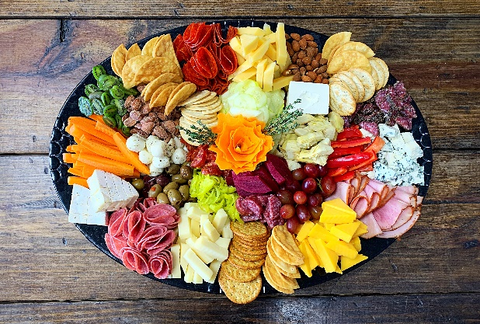
$85 for small (serves up to 20), $138 for Medium (serves up to 35), $190 (serves up to 50)

Harvest Table Display - Three artistically arranged display trays: Vegetable Crudité with Asiago peppercorn Ranch, Fresh Cut Fruit and Berries, and a Cheese Board with Domestic and Imported Cheeses. Three Cold Dips: Tomato-Basil Bruschetta, Cold Spinach Dip, and Red Pepper Hummus, served in large martini glasses. Accompanied by assorted crackers, herbed crostini, & pita chips, as well as olives and pickles. Medium $495 (Serves 30-55), Large $750 (serves 55-80)
*Drop off is an upcharge
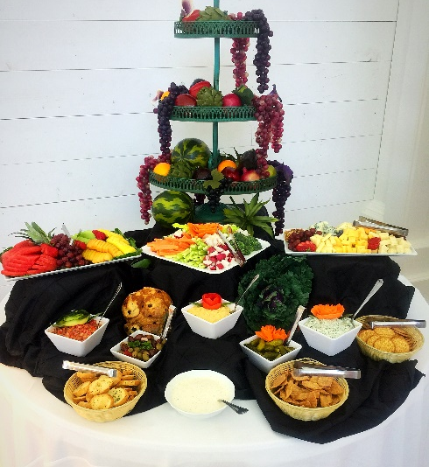
Herb Crusted Beef Tenderloin Display - Seared beef tenderloin served with crispy tobacco onions, horseradish cream, whole grain mustard, and potato rolls - Market price
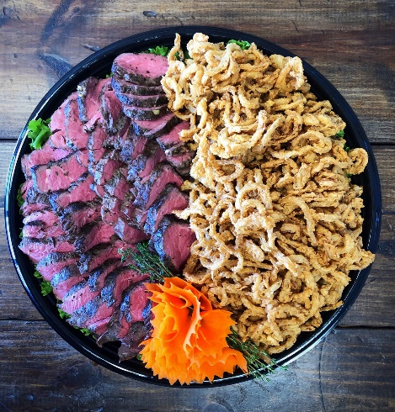
Smoked Brisket Display - Hickory Smoked BBQ Brisket served with crispy tobacco onions, served with BBQ sauce and rolls Market Price
Vegetable Crudité Display - Freshly cut carrots, celery, broccoli, sugar snap peas, grape tomatoes, cucumber, and jicama. Served with Asiago Peppercorn Ranch and garnished with carved radish flowers. $2.25 pp
Fried Chicken Bite Platter - Tender white meat chicken bites crisp fried and served with BBQ, buttermilk ranch, and Dijon honey mustard dipping sauces. $3.50 pp (6 piece)
Smoked Salmon Béarnaise Display- Smoked salmon display with herbed cream cheese spread, hard cooked eggs, capers, onions, lemon slices, and dill creme fraiche, served with crostini – Market Price
Cherry Bourbon Smoked Pork Tenderloin Display- Applewood smoked pork tenderloin with cherry-bourbon compote $4.00 pp
Cheese Board - Domestic & Imported Cheese Display served with assorted crackers and fresh fruit garnish. $4.50 pp

Desserts - See a full listing of dips online under the menu tab

Assorted Dessert Bars - Pecan Chocolate Chunk, Luscious Lemon, Chocolate Raspberry Tango, and Meltaway $3.00 pp
Cobbler - Peach or Apple fruit Cobbler, Bulk or in Cups $40 half pan, $4 per cup
Banana Pudding – Banana Pudding with fresh bananas and vanilla wafers, Bulk or Cups $40 per half pan, $4.00 pp
Pie – Chocolate Cream, Pecan, Apple, or Pumpkin $24 (8 Slice)
Chocolate Sheet Cake Cups - Moist, rich chocolate fudge sheet cake with a pecan fudge icing, can be served with a raspberry swirl to top it off by request $4.00 pp
Bread Pudding – Blueberry, Cinnamon Raisin, Pumpkin, Raspberry or Strawberries and Cream $50 per half pan
Cheesecake – New York style cheesecake with choice of topping: Caramel Apple, Chocolate Caramel, Lemon Curd, Strawberry, Raspberry, Oreo, or Praline $45 (12 slice)
Gourmet Chocolate Mousse Cups - Pecan Chocolate Chunk, Luscious Lemon, Chocolate Raspberry Tango, and Meltaway $3.00 pp
Lemon Glazed Vanilla Cake Cups- Moist vanilla cake iced with lemon glaze, topped with raspberry drizzle, garnished with fresh raspberries $4.00 pp
Assorted Jumbo Cookies or Chocolate Brownies - Individually Wrapped or on a platter $1.50 each
Assorted Mini Tarts - An assortment of three types of bite sized tart shells filled with lemon, chocolate mousse, pecan, raspberry and banana pudding fillings. Topped with fresh berries $2.00 pp
Dessert Platter - An assortment of scratch-made mini tarts, jumbo cookies, and bars $4.75 pp
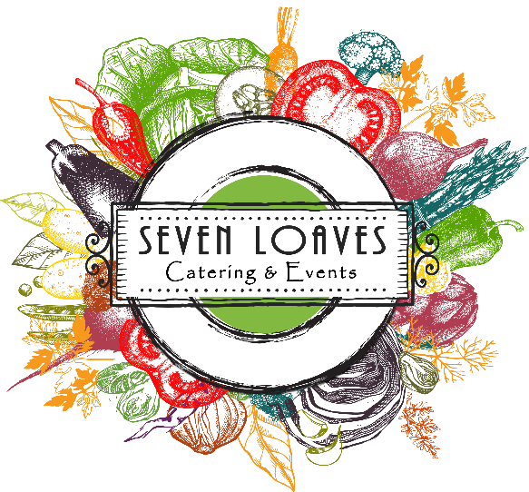
Prices do not include staffing, delivery charge, service charge or sales tax.

